Project Title: | Date Prepared:
Sample Gantt Chart
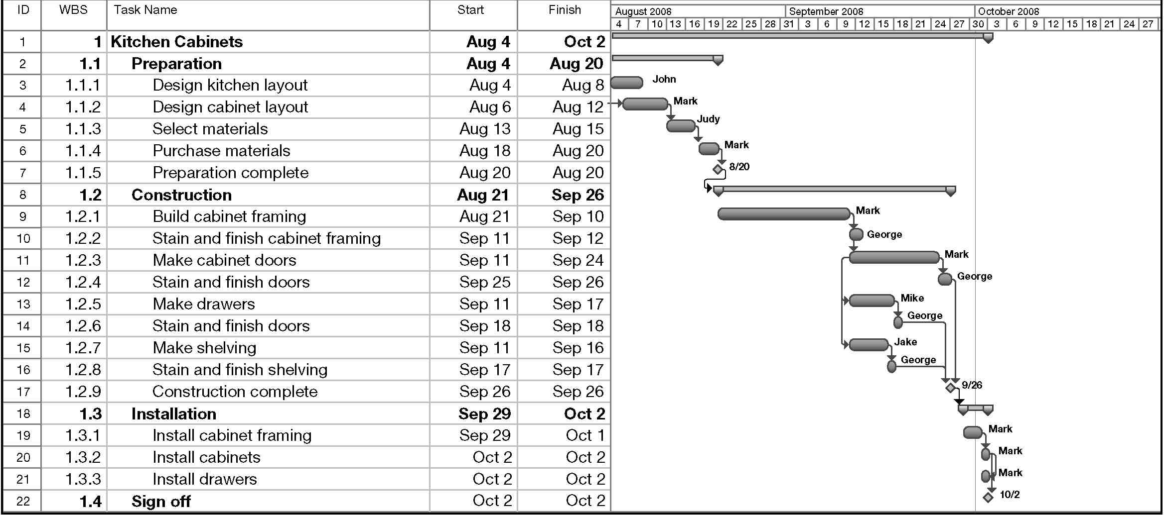

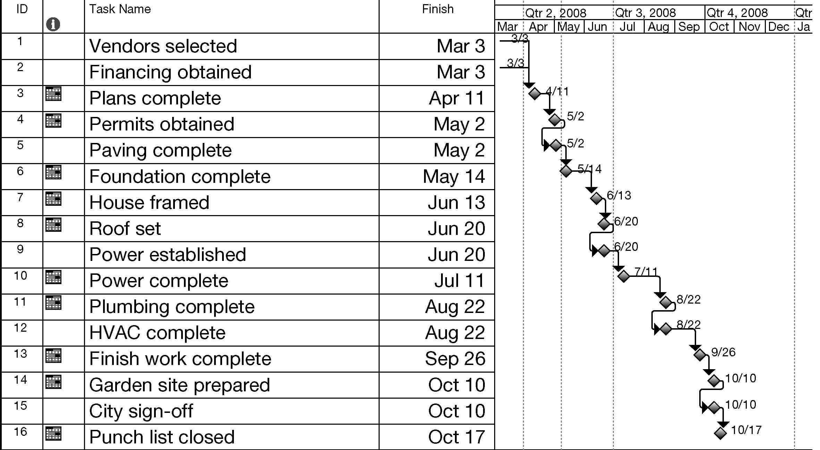
Sample Milestone Chart

